POWER QUALITY COMPARISON BETWEEN VARIOUS TYPES OF RENEWABLE ENERGY
Nor Asrina Binti Ramlee
School of Engineering & Technology, University College of Technology Sarawak
∗For correspondence; E-mai: asrina@ucts.edu.my
ABSTRACT: Nowadays, government is actively searching for alternative sources of fossil fuel due to its limitation and increasing cost. Thus, government increased the implementation of renewable energy sources such as wind, solar and hydro to have sustainable growth and social progress. Among them all, the cleanest power sources must be identified to provide better service to customers. This paper presents a work on power quality comparison between on grid and off grid renewable energy. The on grid power source is from hydro power plant. Solar and wind power are the sources for the off grid renewable energy. The power quality in this research will be compared by detecting voltage sag and voltage swell event in the power generated from the power sources. By eliminating the events, the percentage of the clean signal occurred in every sources will be calculated. The highest percentage of the clean signal in the power source is identified as the cleanest renewable energy power source. The method is developed by using Microsoft Excel. The real interrupted signal data will be obtained from Energy Management & Storage System. The database will be used in comparing the power quality between the various types of renewable energy mentioned before. The results show that on grid power source produced the cleanest energy. Then, followed by solar and wind power source.
Keywords: Renewable energy, power quality, voltage sag, voltage swell, wind power, solar power

- INTRODUCTION

Renewable energy (RE) is a field that began hotly discussed and developed over the past decade. RE is generally defined as energy that is collected from resources which are naturally replenished on a human timescale, such as sunlight, wind, rain, tides, waves, and geothermal heat [1]. Starting from 2008, Sarawak Energy Berhad (SEB) is studying the potential of wind energy as a source of renewable energy that can be applied in Sarawak [2]. SEB is looking for a suitable area in Sarawak for harvesting wind energy which would be more economically, socially and environmentally viable. However, the quality of power is an important element that should be considered to identify the best energy and worthwhile to explore in our country.
The increasing use of electronic and computing equipment has led to a great concern to power quality issues of electric utilities. Electric utilities control the voltage levels and quality but unable to control current. Thus the utilities should control and maintain the bus voltage quality all the times to get clean power [3] (P. Malathy, 2014).Therefore, power quality can be considered as voltage quality. Voltage sag and swell occurred in the system must be analyzed in order to investigate the voltage quality. Thus, the power quality in this research will be compared by detecting voltage sag and voltage swell event in the power generated from the power sources.

- RENEWABLE ENERGY

RE power plant is the alternative taken by government to provide electricity because of the increasing energy demand nowadays. Malaysia located in the equatorial region of the globe. It’s tropical whether experienced heavy rainfall and has abundant sunshine and solar radiation. Solar power, as well as other renewable energy sources is an important item in the Government's Economic Transformation Programme. Marking a new phase of RE development in Malaysia, the nation’s largest solar photovoltaic (PV) power plant was commissioned in December 2013. It is 10.3MW facility located in Gemas, Negeri Sembilan and integrates more than 40,000 units of poly-crystalline solar PV modules [4]. Several places in Sarawak have been identified to have the potential to generate high solar energy due to high solar radiation throughout the year especially Bintulu and Miri. SEB is making an impressive progress in supplying electricity in rural area by using solar power. In the Rural Electrification Projects, SEB have installed PV systems in places where supply from the grid may not be possible for years to come [5].
Energy of the wind has been harnessed centuries ago using wind turbines to make electricity or wind mills for mechanical power. Thus, wind power is actually the conversion of wind energy into electrical or mechanical energy. Along with the advancement, a larger utility-scale wind farms that could be connected to electricity grids were developed in the 20th century. Now, wind power is growing rapidly and having doubled in the past three years in United State [6]. Malaysia’s mean annual wind speed is low at no more than 2 m/s. Nonetheless, the wind does not blow uniformly throughout Malaysia and the speed varies according to region and month [7]. Malaysia is now moving towards developing a wind power plant. Thus many researches and pilot tests had been done to explore the potential. Compared to Sabah and Sarawak, Peninsular Malaysia showed the greatest wind power potential in Malaysia [8; 9]. Ministry Of Rural And Regional Development also had installed 8 units of small wind turbine (5– 10 kW) in Sabah & Sarawak for community [10].
Hydropower is the only renewable energy that is commercially viable on a large scale in Malaysia. It is a renewable energy source and produces negligible amounts of greenhouse gases. Yet, the development of a hydropower dam embraces the issues of social, environmental and political issues. In long term, it stores large amounts of electricity at low cost and it can be adjusted to meet consumer demand. Thus, Sarawak has abundant hydropower potential with a total capacity of 108MW installed in 2009. Sarawak plans to increase hydropower capacity to 3500MW by 2015 and 7723MWby 2020, after that 20 GW by 2030 [11]. For meeting the increasing demands from large industrials, Sarawak has announced plans to develop several large hydroelectric projects under the Sarawak Corridor of Renewable Energy (SCORE).

- CLEAN VOLTAGE

The voltage quality in a transmission line is depends on how many disturbances occurs in the system. The fewer disturbances occurred in the system the higher voltage quality or more clean voltage can be produced. In order to investigate the voltage quality, we can analyze the voltage sags and swells that occur in the system. They are the most common disturbances and very important aspect of power quality. As defined by IEEE Standard 1159-1995, IEEE Recommended Practice for Monitoring Electric Power Quality, voltage sag is a reduction in rms voltage on ac power system at the power frequency to between 0.1 and 0.9 pu for a short period of time between half cycle and one minute [12]. While, a swell is an increase in rms voltage or current at the power frequency to between 1.1 and 1.8 pu for durations from half cycle and one minute. The voltage sag and voltage swell signals are as shown in Figure 1.0 and Figure 2.0 respectively.

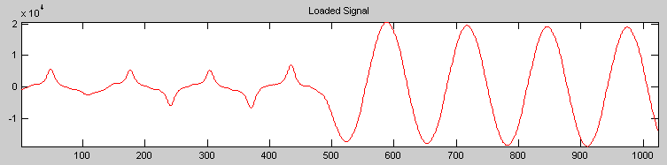 | 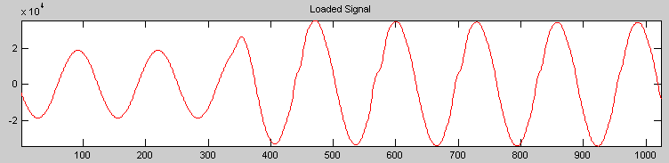
Figure 1.0: Voltage sag | Figure 2.0: Voltage swell

The real interrupted signal data is acquired from Energy Management & Storage System located at Advanced Technology Training Center (ADTEC), Bintulu. Then the analysis method is developed by using Microsoft Excel. Voltage sag and voltage swell event are scanned in all the power sources. The least events occurred in the power source is identified as the cleanest renewable energy power source. The same method and analysis were also applied to determine whether wind power source has higher quality of power compared to solar as the off grid power supply. For the purpose of this study, Bintulu was chosen to be the research area because apparently it was supplied by hydro type of on grid renewable energy coming from Bakun Hydroelectric dam. ADTEC, Bintulu is the center of the research as they have the solar and wind off grid power generator.
- METHODOLOGY

The experiment was carried out by using a unit of EMS which was installed in New Energy Lab, ADTEC, Bintulu. The configuration is as shown in Figure 3.0. The input is the voltage generated from solar panel, wind turbine or from the public grid. All the energy harvested from the power sources will be managed and stored in the EMS unit. Furthermore system components can be controlled via software called Heliocentris Energy System and it record all the data obtained.

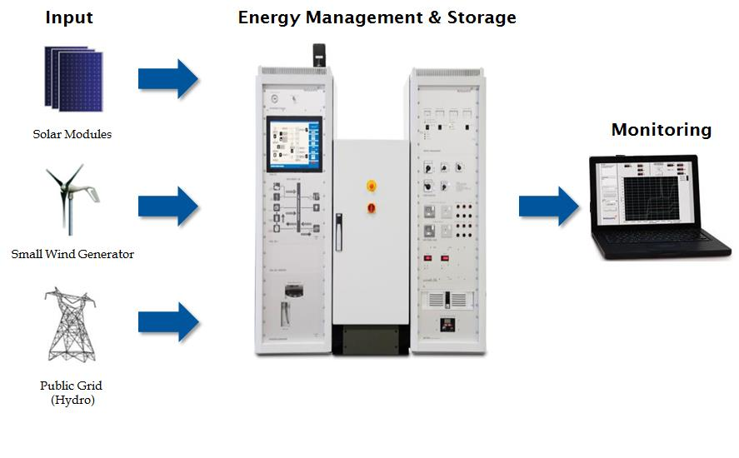
Figure 3.0: Experiment Configuration

The solar panels installed outside the laboratory is as shown in Figure 4.0. There are two panels in parallel and can be controlled remotely from the New Energy Lab. While the wind turbine and the public grid as shown in Figure 5.0 and Figure 6.0 respectively. For the purpose of this project, only the output voltage from the power sources will be recorded. Based on the specification, maximum voltage for solar panel is 24.47Vdc, wind turbine is 24Vdc and public grid is 230Vac.

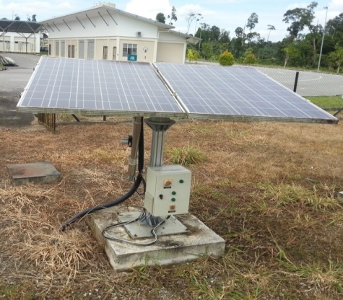 | 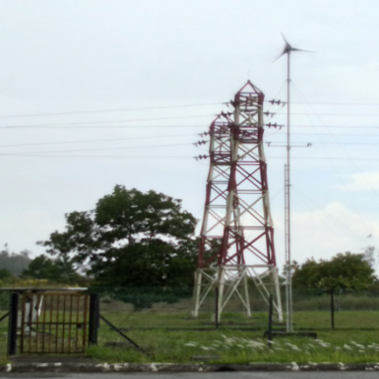 | 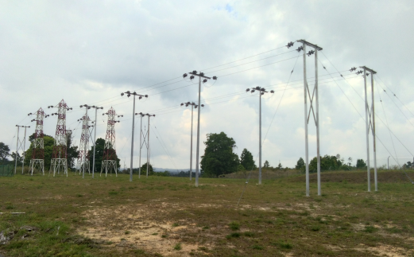
Figure 4.0: Solar Panel | Figure 5.0: Wind Turbine | Figure 6.0: Public Grid

The software aforementioned gives information on the system and its current state. All data recorded can be retrieved in Excel file. The software has two important frontends. The first one is called “System Overview” as shown in Figure 7.0 below. In this frontend a user can control the system. Another frontend is called “Graph” as displayed in Figure 8.0. From this frontend, user can view any required signal.

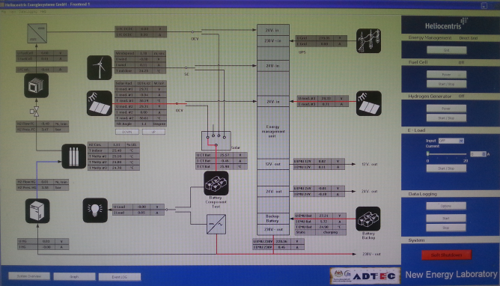 | 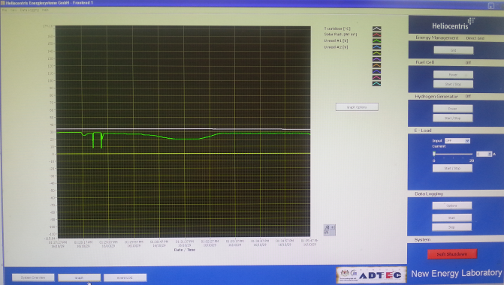
Figure 7.0: System Overview | Figure 8.0: Graph

Before taking data from the solar panel, a preliminary work had been done to determine its optimum tilt angles. In term of position, solar panels are installed differently based on the geographic locations [13]. Solar panels or photovoltaic (PV) arrays are most efficient, when they are perpendicular to the sun's rays. This position maximizes the amount of energy striking the panels and being produced. Two types of angle that influence the position of a solar panel are orientation angle and tilt angle as shown in Figure 9.0. But the tilt angle of the PV array is the key to an optimum energy yield
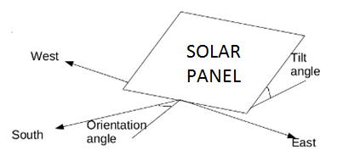
Figure 9.0: Tilt and orientation angles for a solar panel
In this preliminary work, voltage of maximum load is a very important number as it is the actual voltage when it is connected to the solar equipment under standard test conditions [14]. To determine the optimum tilt angle of solar panel, voltage under load test was conducted. Thus, the solar panel is set to orientation angle of 0º and tilt angle of -0.5º, -1º, -1.5º, -10º, 1º, 5º, 10º and 15º. Then the voltage output was recorded until 3000 samples where 1 sample is equal to 1 second and saved them in Excel file. These data are analysed in Excel for voltage sag and swell events The voltage under load test was conducted at random of times ranging from 7am to 6pm.

- RESULTS

3000 samples were retrieved for each power source to be analyzed. These data are analysed in Excel for voltage sag and swell events. As outlined by IEEE Standard 1159-1995, voltage sag event is 10% less than the output voltage, while the voltage swell event is 10% more than the output voltage. Based on the specifications for every power source, the formula used in Excel to identify the good events occurred in the samples are shown in Table 1 below with B2 as the data column.

Table 1: Excel formula used to identify the good events

Power Source | Output Voltage | Excel formula
Solar panel | 24.47V | =IF(B2<22.023,0,IF(B2>26.917,0,1))
Wind turbine | 24V | =IF(B2<21.6,0,IF(B2>26.4,0,1))
Public Grid | 230V | =IF(B2<207,0,IF(B2>253,0,1))

Table 2 shows the result for the preliminary work aforementioned earlier. Obtained that tilt angle of 15º produced the highest percentage of the good events as much as 95.9%. Thus, this set up was used to get the output voltage for solar panel.

Table 2: Percentage of the good events for different tilt angles

Tilt angle | Percentage of the good events (%)
-0.5º | 79.90
- 1º | 86.80
-1.5º | 77.03
-10º | 81.67
1º | 81.67
5º | 80.07
10º | 81.40
15º | 95.90

The Excel formulas shown in Table 1 are used to calculate the total of good events in 3000 samples for every power sources. Then, this total used to determine the percentage of the good events or the power quality by using Equation 1. The higher the percentage the better power quality produced. The result is as shown in Table 3.

$Power Quality=\frac{Total of good events}{3000}×100\%$ Equation 1
Table 3: Percentage of the good events

Power Source | Power Quality
Solar panel | 95.90%.
Wind turbine | 94.17%
Public Grid | 100%

Table 3 shows that public grid which is also a type of on grid power source produced the cleanest energy among the three types of the renewable energy. The on grid power source is come from hydropower plant. It generated 100% of power quality. For off grid types, solar panel produced cleaner energy compared to wind turbine. Solar panel generated 95.90% while wind turbine generated 94.17% of power quality.

- CONCLUSION

From this study, on grid renewable power energy offer better power quality compared to off grid power sources. Among the on grid power sources, solar panel generated higher power quality than wind turbine. Thus, SEB might need to restructure their plan on developing wind power plant in Sarawak. Obviously, hydropower is still playing the most important role in generating electricity without fossil fuels. Sarawak government is developing many projects in Sarawak Corridor for Renewable Energy (SCORE). In the years to come the project is estimated to be able to generate 20GW and channeled into Peninsular Malaysia with high voltage cable connection [15].

ACKNOWLEDGE

Authors would like to acknowledge University College of Technology Sarawak for the financial support to carry out this study through the research project with ID, 1/2016/12. Advanced Technology Training Center (ADTEC), Bintulu is also acknowledged for providing the renewable energy laboratory and equipment.

REFERENCES

[1] Ellabban, O., Abu-Rub, H., & Blaabjerg, F. (2014). Renewable energy resources: Current status, future prospects and their enabling technology. Renewable and Sustainable Energy Reviews, 39, 748-764.
[2] Energy, S. (2010). Introduction to Wind Energy, Research and Developement, Sarawak Energy Berhad, Malaysia. . Retrieved from http://www.sarawakenergy.com.my.
[3] P. Malathy, M. K. (2014). Mitigation of Voltage sag and Harmonics in Grid connected Wind Energy System using STATCOM. IOSR Journal of Dental and Medical Sciences, Volume 13(Issue 4 ), 9.
[4] Bernama. (2015). Amcorp Power Proclaimed The 2015 Frost & Sullivan Malaysia Solar Systems. Company of The Year.
[5] Energy, S. (2013 ). Research and Development on Solar Energy. Retrieved from http://www.sarawakenergy.com.my.
[6] Laboratory, N. R. E. (2010). Wind power today 2010, Wind and water power program, United State.
[7] Sung, C. (2013). Possibility of electricity from wind energy in Malaysia: some rough calculations. In.
[8] Sopian, K., Othman, M. H., & Wirsat, A. (1995). The wind energy potential of Malaysia. Renewable Energy, 6(8), 1005-1016.
[9] Zaharim, A., Najid, S. K., Razali, A. M., & Sopian, K. (2009). Analyzing Malaysian wind speed data using statistical distribution. Paper presented at the Proceedings of the 4th IASME/WSEAS International conference on energy and environment, Cambridge, UK.
[10] Ismail, B. (2009). Exploring wind energy for electricity generation. Renew Summit, 2009.
[11] Aqua Media, I. (2010). Asia’s achievements and challenges discussed in Sarawak. Third International Conference on Water Resources and Renewable Energy Development.
[12] Smith, J. C., Hensley, G., & Ray, L. (1995). IEEE recommended practice for monitoring electric power quality. IEEE Std, 1159-1995.
[13] Harburn, J. (2010). Solar Panel Tilt and Orientation in Australia. Installation Advice, Positioning Solar PV Panel,, Jan. 7.
[14] Beaudet, A. (2016). How To Read Solar Panel Specifications. Retrieved from https://www.altestore.com.
[15] UBM-MES. (2017). Electric, power and renewable energy Malaysia. Retreived from http://www.epremalaysia.com.

